Ways to Help:

Cleaners:
Shelters need cleaning too. Volunteers will be asked to clean the bathrooms and tidy up the shelter room.

Laundry:
At the end of each shelter week, all of the bed and bath linens need to be washed at the local Laundromat.

Transportation of Supplies:
Up to 20 cots and a guest’s shelter tote will need to be transported to each Host Church weekly during the season.

Safe Nights is a 501(c)(3) non-profit, volunteer-driven program, but there are still expenses for transportation and supplies. Monetary donations help offset those expenses, and are 100% tax deductible.

Send donations to:
Safe Nights of Calvert County, Inc.
P. O. Box 3707
Prince Frederick, MD 20678

Volunteer at:
www.safenightsofcalvert.com

Safe Nights Shelter Hosts

All Saints Episcopal
Bethel Way of The Cross
Dunkirk Baptist
Emmanuel Church
Calvert Grace
Jesus the Divine Word Catholic Church
NEWLIFE Church
Life Church Calvert
Huntingtown United Methodist Church
St. John Vianney Catholic Church
St. Paul’s Episcopal Church Prince Frederick
Trinity United Methodist Church
Union Church

Other Congregations include:

Christ Episcopal, Emmanuel United Methodist, Jesus the Good Shepherd Catholic, Our Lady Star of the Sea Catholic, Patuxent Friends, St. John’s United Methodist, Solomon’s United Methodist, Peter’s United Methodist Church, Peter’s Episcopal Church, All Saints Episcopal, Calvert County Baptist Church, Smithville United Methodist Church

Safe Nights of Calvert County
Season 18:
December 8th 2024-February 23rd 2025

Volunteer Training via Zoom:
Nov 16th 10am-11am
Nov 26th 7pm-8pm
Dec 3rd 7pm-8pm

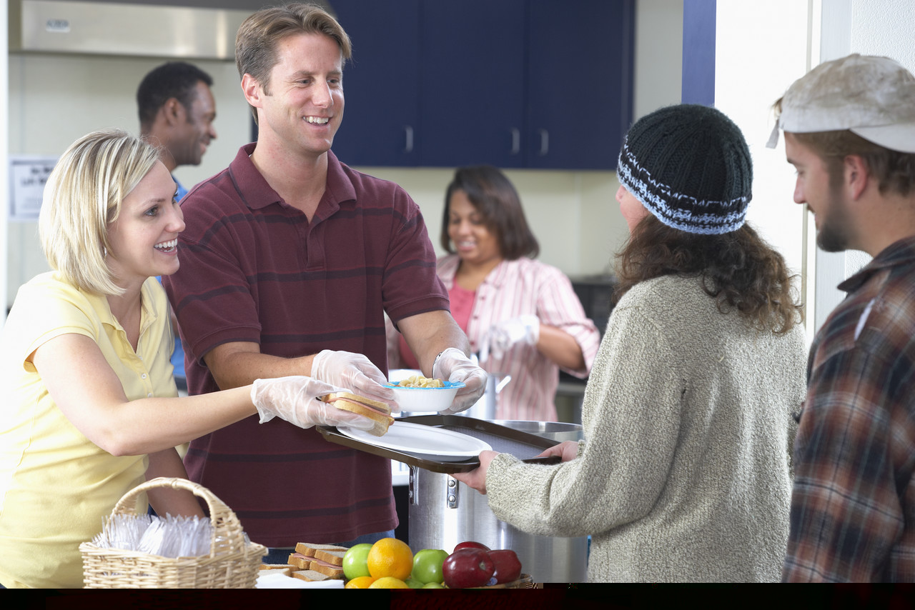

Welcome Volunteers!

There is no exercise better for the heart than reaching down and lifting people up.
John Andrew Holmes Jr., American writer
Safe Nights of Calvert is an interfaith consortium of churches that open their hearts and church homes to the homeless.

What Does Safe Nights of Calvert Provide?

Calvert County faith congregations host shelters for one week each beginning in December and ending February. Shelters are open 7 days a week from 7:00 p.m. – 7:00 a.m. Shelters provide a warm bed and three nutritious meals (breakfast, dinner and a bag lunch) in a safe environment.

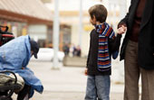

Be not forgetful to entertain strangers for thereby some have entertained angels unawares.
Hebrews 13:2
More Ways to Help:

Setup and Breakdown Shelters:
Assist in setting up and taking down cots and tables and chairs.

Preparing Food:
You may be asked to prepare food at home and bring to the shelter, or help prepare the food in the shelter kitchen.
Breakfast is served at 6:00 a.m. and Dinner is served at 7:30 p.m. You can also make bag lunches to be handed out after breakfast.

Serving Food:
Food servers usually are asked to arrive an hour before breakfast and dinner is to be served. Some host churches have the food brought to the shelter, and some prepare the food at the shelter. You will assist in getting the meal ready and serving the meal.

Be an Overnight Monitor:
As a monitor, you get to know those we are serving. While you are there to greet the guests, you also have responsibilities to enforce the rules. All volunteers who have contact with the guests receive training and sign a confidentiality agreement.

One male and one female monitor must be present while guests are at the shelter. Monitors serve a full shift from 6:30 p.m. to 7:00 a.m. or partial shift, usually, from 6:30 p.m. to 1:00 a.m. or 12:30 a.m. to
7:00 a.m.

Monitors greet the guests, check their paperwork, and have them sign in, receive their medication and log it in. The monitor ensures that the guests follow the rules and documents any incidents that happen on their shift. In the event of an emergency, they call 911 and notify the host coordinator.

As volunteers, we do not have the ability to solve all of the guest’s problems. We leave that to the social workers. We ask that you treat all guests with respect and courtesy but set boundaries. If a guest needs help, refer them to an agency that can assist them, or let the host coordinator know.

